**Project Design Phase II**

**Data Flow Diagram & User Stories**

|  |  |
| --- | --- |
| Date | 7 March 2025 |
| Team ID | SWTID1741172246152964 |
| Project Name | NewsApp:  BA LIVE NEWS |
| Maximum Marks | 4 Marks |

**Data Flow Diagrams (DFD)**

**Level 1: Overview of Data Flow**

1. **User Interaction**:
   * The user interacts with the website by:
     + Searching for news articles.
     + Selecting a news category (e.g., Sports, Politics, Entertainment).
     + Clicking on an article to read more.
     + Subscribing to the newsletter.
2. **News Fetching Process**:
   * The user's search term or category selection is sent to the **NewsAPI**.
   * The **NewsAPI** fetches relevant news articles and returns them to the application.
3. **Displaying News**:
   * The application processes the data and displays a list of news articles.
   * Each article includes:
     + Title.
     + Image.
     + Short description.
     + "Read More" button (links to the full article).
4. **Subscription Process**:
   * The user enters their email in the subscription form.
   * The email is stored in the database (or sent to a backend service).
   * A confirmation message is displayed to the user.

**Level 2: Detailed Data Flow**

1. **User Searches for News**:
   * User enters a search term in the search bar.
   * The search term is sent to the **NewsAPI**.
   * The **NewsAPI** returns a list of articles matching the search term.
   * The application displays the articles in a card format.
2. **User Selects a Category**:
   * User clicks on a category button (e.g., Sports, Politics).
   * The category value is sent to the **NewsAPI**.
   * The **NewsAPI** returns articles related to the selected category.
   * The application updates the news feed with the new articles.
3. **User Reads an Article**:
   * User clicks on the "Read More" button for a specific article.
   * The application opens the full article in a new tab (using the article URL from the API).
4. **User Subscribes to Newsletter**:
   * User enters their email in the subscription form and clicks "Subscribe".
   * The email is sent to a backend service for storage.
   * A confirmation message ("Thank you for subscribing!") is displayed.

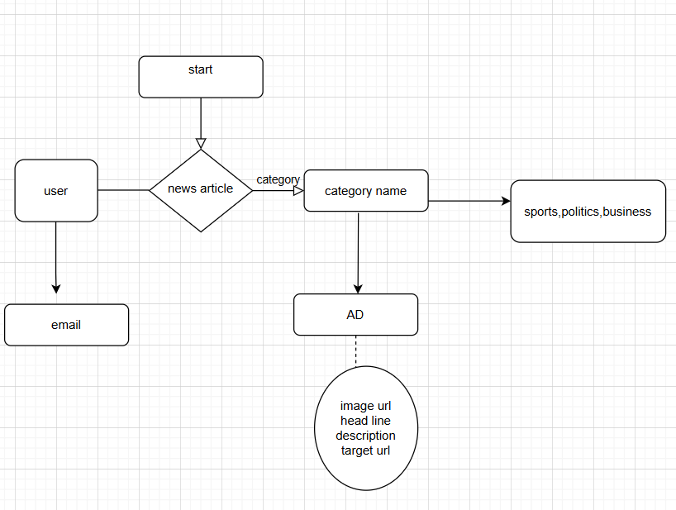

| **User Type** | **User Story Number** | **User Story / Task** | **Acceptance Criteria** | **Priority** | **Release** |
| --- | --- | --- | --- | --- | --- |
| Customer (Web User) | USN-1 | As a user, I can search for news articles by entering keywords. | I can see a list of news articles related to the keywords I entered. | High | Sprint-1 |
| Customer (Web User) | USN-2 | As a user, I can filter news by categories (e.g., Sports, Politics, Entertainment). | I can see news articles related to the selected category. | High | Sprint-1 |
| Customer (Web User) | USN-3 | As a user, I can read the full article by clicking "Read More". | I am redirected to the full article in a new tab. | High | Sprint-1 |
| Customer (Web User) | USN-4 | As a user, I can subscribe to the newsletter by entering my email. | I see a confirmation message after submitting my email. | Medium | Sprint-2 |
| Customer (Web User) | USN-5 | As a user, I can easily navigate back to the home page. | I can click the "Home" button and return to the main news feed. | High | Sprint-1 |
| Customer (Web User) | USN-6 | As a user, I can view trending news articles on the home page. | I can see a list of trending articles without searching. | High | Sprint-1 |
| Customer (Web User) | USN-7 | As a user, I can see ads relevant to my interests. | I see ads with images, headlines, and "Learn More" buttons. | Low | Sprint-2 |
| Admin | USN-8 | As an admin, I can manage the ads displayed on the website. | I can upload new ads, update existing ones, and remove outdated ads. | Medium | Sprint-3 |